NTestController Design Document

Version 1.0

Contents
Contents 1
Purpose: 2
Requirements: 2
Solution: 3
NTestController command line syntax: 4
Options: 4
Examples: 4
NTestController.xml file: 5
Format of the file NUnit-Reader.dll input file: 6
Future Enhancements: 6
Appendix: 7
NTestController Class Diagrams: 7
Activity Diagrams: 7
NTestController main program flow: 7
Worker Thread flow: 8

Purpose:
The purpose of the NTestController is to run a set of individual tests on set of computers and continue running different tests on the computers until the test queue is empty. The reason for this is to distribute the test load evenly across multiple machines, and if one machine goes down, tests will simply bypass that machine and run on the other machines.
Another feature is that the NTestController can re-run tests that fail. This helps to improve results and reduce the time required to investigate product defects because flaky tests will most likely pass when re-run. All test results will be kept, including all retries so people can try to find out why the test failed on the initial attempts. This will help to find which tests might be flaky so they can be fixed.
The NTestController is Open Source and uses a plugin based architecture to allow anyone to customized it to their needs. The first version of NTestController will come default with plugins designed to run NUnit tests.

Requirements:
- The code must be clean, modular, and well documented.
- NTestController should be a console application.
- NTestController should read a list of tests that need to be run.
- NTestController should read its configuration from an XML file.
  - The configuration should indicate which test machines to use, credentials, and anything else needed by the plugin that executes the tests.
  - The configuration should allow defaults for values not specified on a per machine basis.
- NTestController should send tests (one at a time) to all machines that are waiting for tests.
  - NTestController should collect the XML result files after each test finishes.
    - If a test fails, NTestController should inject the console output from the test runner into the <stack-trace> tag of the XML file of the test that failed, as well as the name/IP of the machine where the test ran.
  - If a test fails, NTestController will call a post-test function in the Executor plugin that could do custom actions such as copy product log files to aid in failure analysis. Other things the post-test function could do include checking the if the product services are running and restart them if needed.
  - If a test fails (but doesn’t timeout), it should be put into the back of the test queue so it can be run again (unless it has used up all of its retries).
    - When a test gets re-run, its existing XML result file should be renamed by appending a .1 or .2 … to the filename to indicate the attempt number before the new XML result file is copied to Jenkins. This will keep a history of failed attempts so we can try to figure out why it didn’t pass the first time.
- nTestConroller should have a timeout value per test (set in the configuration) to force the test runner to kill tests that take too long (and are presumably stuck). This will keep stuck tests from preventing other tests from running.
  - Tests that timeout should NOT be added back into the queue (i.e. should not be re-run).
- NTestController should log information with 5 standard levels of logging: ERROR, WARNING, INFO, DEBUG, TRACE. Errors & warnings should go to stderr; the rest should go to stdout.
- NTestController should be multi-threaded and handle concurrency properly.
- Multiple NTestController instances should be able to run concurrently.
- NTestController should return 0 if all tests passed, a positive number indicating the number of tests that failed, or a negative number if a fatal error occurred.

Solution:

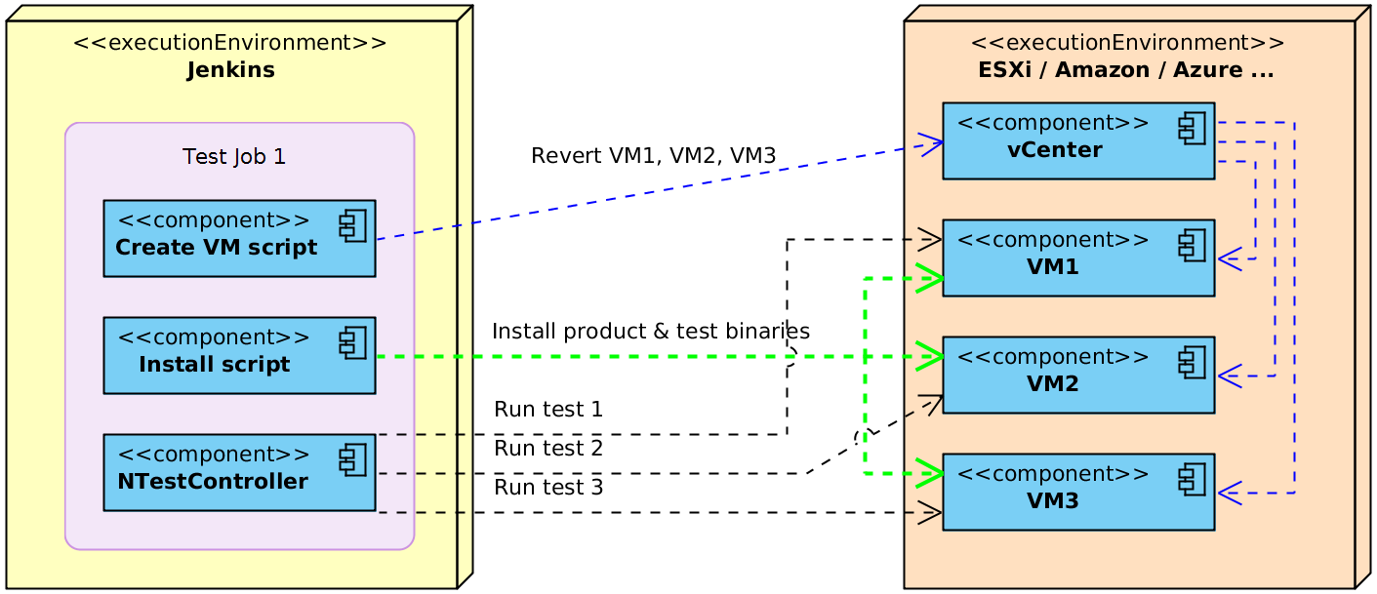
NTestController will typically be run on Jenkins in conjunction with scripts to revert test VMs and install the latest product & test binaries. Jenkins could have multiple NTestController jobs running simultaneously (for example, there could be Windows 2008 and 2012 jobs running at the same time, or different versions of the product). In the diagram above, we only show a single NTestController job on Jenkins for simplicity.
First a revert script reads the NTestController.xml file to find out which VMs to create/revert and which VM Server to contact to revert them as well as their image name. It then tells the VM Server to create or revert each VM.
After creating all the VMs, another script reads the NTestController.xml file to find out which VMs to configure and how they should be configured. It then installs the latest version of the Product, Test binaries, NUnit… onto each VM and configures them appropriately.
Then once all machines are properly configured, NTestController starts running. It reads the NTestController.xml file and the list of tests to be run and stores the tests in a queue; then it starts one worker thread for each machine where tests will run. Each worker thread pops a test off the queue and begins running it on the test machine. Once the test is finished, if the test failed it also injects the hostname where the test ran as well as the NUnit stdout & stderr into the <stack-trace> tag of the result XML file; if the test failed and hasn’t exceeded its max number of retries, the test is reinserted into the back of the test queue. Information about which tests passed/failed/time-out as well as the number of times the test has been retried is stored in an XML structure. Tests that time out are not retried because of the likelihood that they will time out on the retries also.
Once the test queue is empty, all the worker threads die and NTestController exits. NTestController returns 0 if all tests pass, a positive number indicating the number of tests that failed, or a negative number if NTestController experienced a fatal error.
Once NTestController exits, another script merges all the NUnit XML results together so Jenkins can display the results. Jenkins also archives logs, and anything else that will aid in diagnosing test failures.

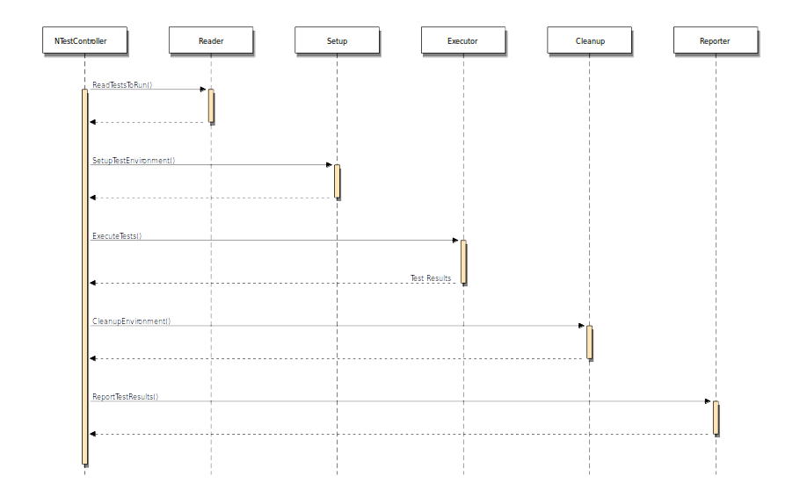

NTestController command line syntax:
NTestController -c <XML file> -o <directory> [-f <csv file>] [-r <number>] [-R <0-99>] [--dry-run] [--verbose <mode>]

Options:
-c, --config The XML file that contains a list of target machines, plugin info & other config data.
-o, --output The top-level directory where the XML test results are stored.
-d, --dry-run (optional) Don't run tests. Just simulate what would normally happen.
-f, --file (optional) A CSV file containing a list of test names. If not specified, tests are read from stdin.
-r, --retry (optional) Number of times to retry failed tests.
-R, --retry-threshold (optional) The percentage of retried tests that should pass to allow another retry attempt.
-v, --verbose (optional) (Default: Info). The log level to use (i.e None, Error, Warning, Info, Debug, Trace).

Examples:
Run smoke tests with default options:
NTestController –c NTestController.xml –o C:\Test_Results –f smoke_tests.csv
Run nightly tests and retry failed tests up to 3 times:
NTestController –c NTestController.xml –o C:\Test_Results –f nightly_tests.csv –r 3
Run weekly tests and also display debug output:
NTestController –c NTestController.xml –o C:\Test_Results –f weekly_tests.csv --verbose debug
Simulate running all tests (don’t actually run the tests):
NTestController –c NTestController.xml –o C:\Test_Results –f all_tests.csv --dry-run

NTestController.xml file:
This is the configuration file that you would pass to NTestController using the --config command line argument.
<ntest_controller>
<plugins>
<plugin type="TestReader" path="C:\NTestController\plugins\NUnit-Reader.dll" />
<plugin type="EnvSetup" path="C:\NTestController\plugins\Null-Setup.dll" />
<plugin type="TestExecutor" path="C:\NTestController\plugins\NUnit-Executor.dll" />
<plugin type="EnvCleanup" path="C:\NTestController\plugins\Null-Cleanup.dll" />
<plugin type="TestReporter" path="C:\NTestController\plugins\NUnit-Reporter.dll" />
</plugins>

<!-- REQUIRED - Only 1 <defaults> tag allowed.
All tags inside <defaults> are required if they are not specified in the computer nodes below.
Only 1 of each is allowed. -->
<defaults>
<computer timeout="600" />
<credentials username="Administrator" password="password" />
<nunit path="C:\Program Files (x86)\NUnit 2.6.4\bin\nunit-console.exe" />
<test_results path=".\Test_Results" />
<working_dir path="C:\Jenkins\workspace\foo" />
</defaults>

<!-- REQUIRED - Multiple <platform> tags allowed.
os: The OS name.
version: The OS version.
cpu: Should be either "x86" or "x64". -->
<platform os="windows" version="2012R2" cpu="x64">

<!-- REQUIRED - Multiple <computer> tags allowed in each <platform> section.
hostname: The hostname, alias or IP Address of the target test machine.
timeout: (optional if specified in defaults) The max number of seconds to wait for each test to finish. -->
<computer hostname="TestVM1" timeout="600">

<!-- OPTIONAL if specified in defaults - Multiple <env_var> tags are allowed per <computer> section. This
overrides any environment variables with the same name in the <defaults> tag for this machine.
Used to add environment variables for the thread responsible for running tests on this computer.
Ex. This might be necessary if your tests need a different config file for each computer...
name: The environment variable name.
value: The value for this variable. -->
<env_var name="CONFIG_FILE" value=".\conf\TestVM1.conf" />

<!-- (used by the NUnit-Executor.dll) OPTIONAL if specified in defaults - Only 1 <nunit> tag allowed per <computer> section.
This overrides the nunit path in the <defaults> tag for this machine.
path: The path to nunit-console on the target machine. -->
<nunit path="C:\Program Files (x86)\NUnit 2.5.9\bin\net-2.0\nunit-console.exe" />

<!-- OPTIONAL if specified in defaults - Only 1 <test_results> tag allowed per <computer> section. This
overrides the test_results path in the <defaults> tag for this machine.
path: The relative path where the test results will be collected on the local machine. This is
relative to the path specified in the --output command line argument. -->
<test_results path=".\Temp\Test_Results" />

<!-- OPTIONAL if specified in defaults - Only 1 <working_dir> tag allowed per <computer> section. This
overrides the working_dir path in the <defaults> tag for this machine.
path: The relative working directory path for any sub-processes that are executed. -->
<working_dir path=".\bin" />

</computer>

<!-- All test machines must be defined by a computer tag -->
<computer hostname="TestVM2" timeout="700" >
<env_var name="CONFIG_FILE" value=".\conf\TestVM2.conf" />
</computer>

</platform>
</ntest_controller>

Format of the file NUnit-Reader.dll input file:
The file containing the list of tests to run is a pipe delimited text file with the following line format (whitespace before & after each pipe is ignored):
<test DLL name> | <test name>
A list of tests can be generated by another tool (yet to be written) that uses reflection to extract the list of tests from each test DLL.
Example:
"C:\MyTestApp\bin\SomeNamespaceTests.dll" | SomeNamespace.MyClass.Test1
"C:\MyTestApp\bin\SomeNamespaceTests.dll" | SomeNamespace.MyClass.SubClass.Test2
"C:\MyTestApp\bin\SomeNamespaceTests.dll" | SomeNamespace.MyClass.ParamTest(3.14, “pi”)

Future Enhancements:
The following is a list of features that will be added in future versions of NTestController.
- NTestController will remember where tests ran and if they fail, they will be re-run on different machines.
- NTestController will store the execution time of each test in a database and use previous execution times to dynamically set the timeout value for the test.
- If NTestController is killed or crashes, it should be able to continue running tests from the point it was at rather than re-running all the tests.
- NTestController will be able to run multiple concurrent tests on each test machine.
- NTestController will have different queues for different sets of tests, and queues will run tests on specified test machines.
- Tests that are marked as not parallelizable will run one at a time on certain queues or wait until all other tests are finished before running one at a time.
- NTestController will keep track of the start & end times of all tests that it runs so when a test fails, it can inject a list of other tests that were running at the same time into the test report output.

Appendix:

NTestController Class Diagrams:

Activity Diagrams:

NTestController main program flow:
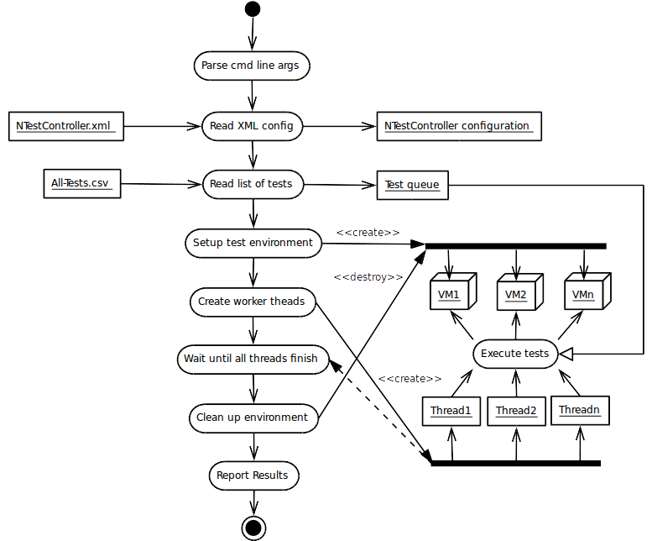

Worker Thread flow:
